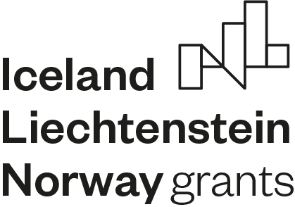 Portugal & Norway – Partnerships

for Innovation- FBR Open Call #2

Checklist of Documents required:

Only applications received in full before the deadline defined for each cut-off can be evaluated in that same period.

Please check all the documents that must be sent to the e-mail bilateralrelations@eeagrants.gov.pt :

Term of Responsability
Statutory documents of the applicant entity
Proof of the regularized situation with the Tax Authority
Proof of the regularized situation with the Social Security
Certificate proving the VAT regime
Letters of intent from Donor States Partners
Letters of intent from national partners and/or from other beneficiary states (if applicable)
Unique or autonomous undertaking declaration (if applicable)
Budget and timeline

